

**Name:** Mosroor Mofiz Arman

**ID:** 1921079642

**Course:** CSE323

**Section:** 05

**Submitted to:**

Dr. Saeed Mahmud Ullah (SMU1)

Adjunct Faculty

Department of Electrical & Computer Engineering

North South University

**Date:** 13-06-2023

**Process Management in Windows Operating System**

Process management is a fundamental aspect of any operating system, including Windows. It encompasses creating, terminating, scheduling, synchronizing, and allocating resources to processes. The Windows operating system employs a sophisticated process management system to ensure the efficient execution of multiple tasks and provide users with a responsive computing environment. This research paper aims to delve into the critical aspects of process management in the Windows operating system, shedding light on its functionalities, mechanisms, and benefits.

As an active entity, a process encompasses more than just program code. It includes the current activity, program counter, processor register contents, process stack, data section, and potentially a dynamically allocated heap. While a program is a passive entity when it is stored as an executable file, when the file is loaded into memory, a process is generated that enables the program to run and use related resources. Multiple processes can be associated with the same program, each representing a separate execution sequence with variable data, heap, and stack sections. Furthermore, a process can spawn additional processes during its runtime and serve as an execution environment for other code, as demonstrated by the Java virtual machine interpreting and executing Java programs using native machine instructions. A process's state varies while it runs. The current activity of a process contributes to defining some of its states. One of the states mentioned above is possible for a process:

**New:** The process is being created.

**Running**: Instructions are being executed.

**Waiting:** The process is waiting for some event to occur (such as an I/O completion or reception of a signal).

**Ready:** The process is waiting to be assigned to a processor.

**Terminated:** The process has finished execution.

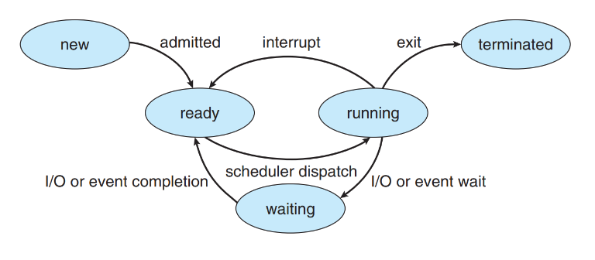

*Figure: Diagram of process state*

These names are random and differ between operating systems. However, all systems contain the states that they stand for. Additionally, specific operating systems distinguish process states more precisely. It is crucial to understand that on any given processor, only one process can be active at any given time.

In an operating system, the CPU performs context switches from one process to another. A context switch is a mechanism that enables the CPU to transition its execution from the currently running process to a different process. This switch occurs to provide fair and efficient CPU utilization among multiple processes. During a context switch, the operating system saves the state of the currently running process, including its program counter, register values, and other relevant information, into its process control block (PCB). The PCB serves as a repository for storing the necessary information about a process. Subsequently, the operating system retrieves the PCB of the next process to be scheduled and restores its saved state. This allows the CPU to resume the execution of the new process seamlessly.

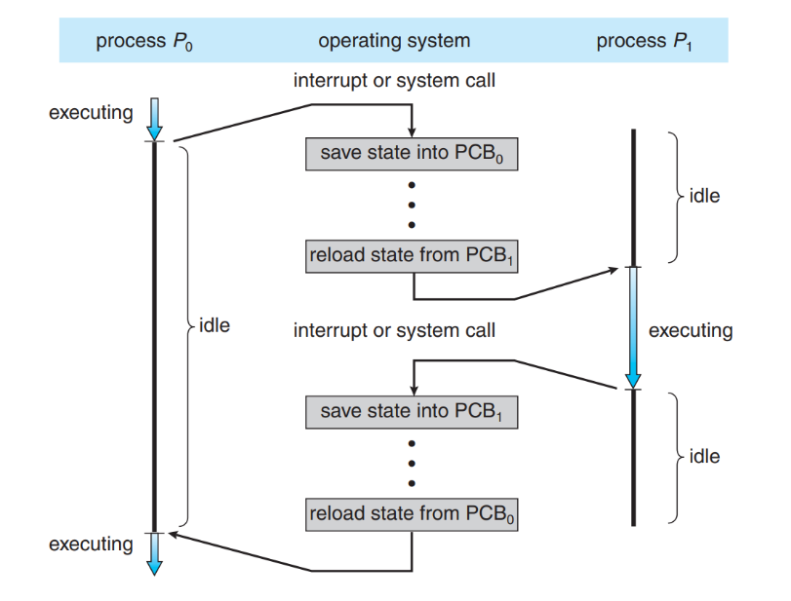

*Figure: Diagram showing CPU switch from process to process.*

In the Windows operating system, a process represents a running instance of a program. When a user initiates an application or executes a command, the operating system creates a new process to handle that task. The process creation process involves allocating system resources, such as memory, to the newly created process. Windows follows a hierarchical process model, where processes can spawn child processes, forming a tree-like structure. This model allows for the organization and management of related processes, facilitating communication and resource sharing.

Once a process completes its execution or is no longer needed, it undergoes termination. Windows provides several methods for terminating a process. Voluntary termination occurs when a process initiates the termination, typically by reaching the end of its execution or encountering an error condition. On the other hand, forced termination occurs when the operating system terminates a process forcibly, usually due to a system-level intervention or when a process becomes unresponsive. Termination ensures the release of allocated resources, freeing up system memory and preventing leaks.

Process scheduling plays a vital role in a multitasking environment, where multiple processes compete for system resources. Windows utilizes a preemptive priority-based scheduling algorithm to manage the execution of processes. Each process is assigned a priority level, and the scheduler determines the order in which processes are executed based on their priority. Windows employs dynamic priority adjustments to ensure fairness and responsiveness. The scheduler utilizes time slicing and thread prioritization to efficiently allocate CPU time to different processes. This approach ensures that each process receives a fair share of the system resources, maintaining a balanced and responsive system.

In the operating system, processes are organized into queues for efficient management. When processes enter the system, they join the job queue. The ready queue holds processes in main memory that are ready to execute. Device queues are used for processes waiting for specific events, such as I/O requests. A process transitions between the ready and waiting states, represented by queues, based on events like I/O requests or creation of child processes. The process cycle continues until termination, at which point it is removed from all queues and its resources are deallocated.

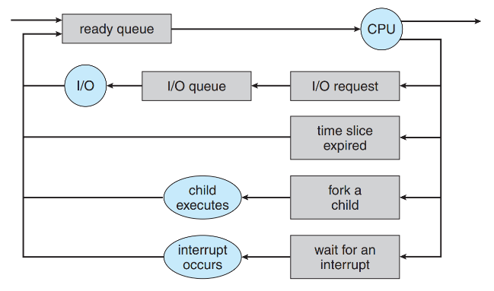

*Figure: Queueing-diagram representation of process scheduling.*

In the operating system, processes can be independent or cooperating. Independent processes do not impact others while cooperating processes share data and interact. Process cooperation is valuable for information sharing, computation speedup, modularity, and user convenience. Interprocess communication (IPC) mechanisms are necessary for cooperating processes.

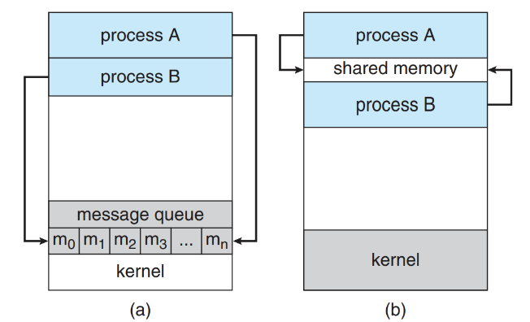

*Figure: Communications models. (a) Message passing. (b) Shared memory*

Two standard models are shared memory, where processes exchange data through a shared region, and message passing, where processes communicate via messages. Message passing is suitable for small data exchanges and distributed systems, while shared memory can be faster. Recent research suggests that message passing performs better on systems with multiple cores. Further exploration of shared-memory and message-passing systems follows.

The efficient allocation of system resources is essential for optimal performance and stability. Windows manages resource allocation for processes, including CPU time, memory, disk I/O, and network bandwidth. The operating system utilizes virtual memory management and page swapping to allocate memory among active processes efficiently. Windows employs a demand-paged virtual memory system, where memory pages are loaded into physical memory only when needed, effectively utilizing limited physical memory resources. Additionally, Windows provides mechanisms for prioritizing and controlling resource usage, preventing one process from monopolizing system resources and adversely impacting system performance.

Windows offers a range of tools and utilities to monitor and control processes effectively. The Task Manager makes vital information on currently active processes, system performance, and resource usage available in real time. Users can monitor CPU and memory utilization, terminate or rank programs, and identify performance problems. The Task Manager provides insights into process behavior, enabling users to identify and address resource-hungry or misbehaving processes. Windows also provides Application Programming Interfaces (APIs) and command-line utilities for programmatically managing processes, empowering developers to build process management capabilities into their applications.

Process management is a vital component of the Windows operating system, ensuring the smooth execution of tasks and efficiently utilizing system resources. By effectively managing process creation, termination, scheduling, synchronization, and resource allocation, Windows provides users with a responsive, stable, and productive computing environment. The hierarchical process model, preemptive priority-based scheduling algorithm, synchronization mechanisms, and resource allocation techniques contribute to the overall performance and reliability of the system. With its robust process management capabilities and user-friendly tools, Windows empowers users and developers to optimize process execution, maximize resource utilization, and maintain a seamless computing experience.

In conclusion, process management in the Windows operating system is a complex and crucial system that involves various tasks and mechanisms. Understanding the functionalities and benefits of process management in Windows is essential for users and developers to maximize the operating system's capabilities. The efficient management of process creation, termination, scheduling, synchronization, and resource allocation ensures a responsive, stable, and productive computing environment. By continuously improving and optimizing its process management system, Windows remains at the forefront of providing a seamless computing experience for its users.